PROJECT Build Platform from scratch!

Objective To build a platform filled with various objects and behaviors.

PROJECT DESCRIPTION

Use various assets included in GDevelop framwork to set up multiple scenes.

Information About This Project

The initial game screen consists of following objects or “assets” you will incorporate.

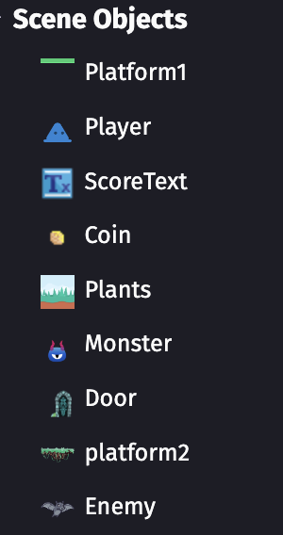

Base scene 1

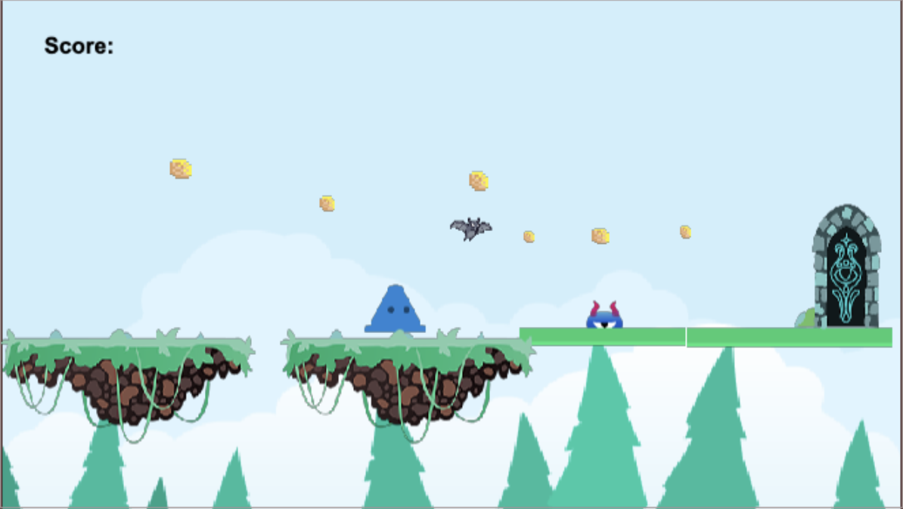

Developer Interface

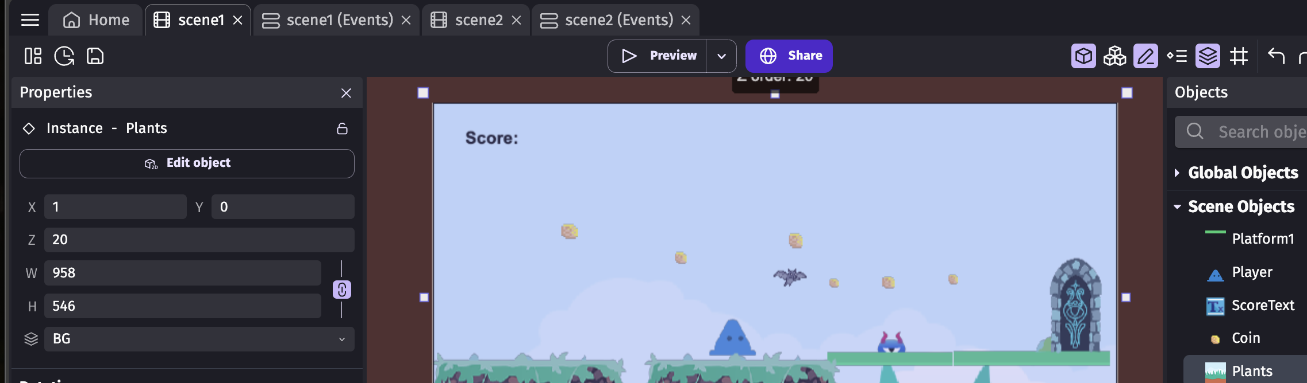

Steps to Complete This Project

STEP 1 Open a Web Browser and travel to a Web Link

Login into your account at https://editor.gdevelop.io/

STEP 2 Getting Started

To create a project from the Home tab click on Build then Create a project as shown below.

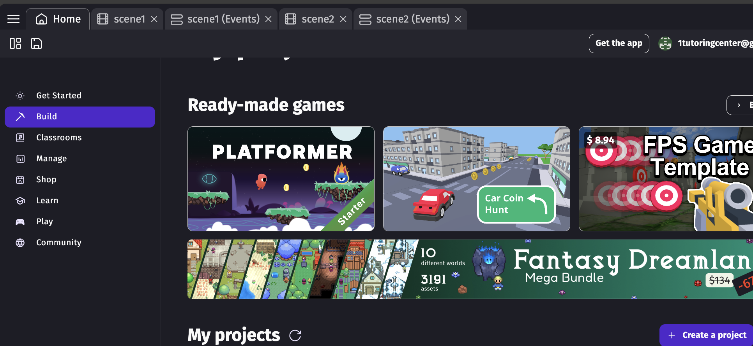

STEP 3 Game settings

Set up your game assest which will be consisting of all Sprite figures including Players, Enemies, Doors, Backgrounds, etc., as follows

A. Add a New Object
Click the Objects Panel tab on the right side of the scene editor.

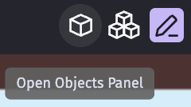

B. Click the  button to add a new object.

C. Choose a Sprite Object
In the Add a new object dialog, select Sprite.
Click Add to create a new sprite object.

D. Configure the Sprite Object
In the Object Properties panel, name your sprite (e.g., "Player").
Click the + button under the Animations section to add an animation.

Click the pull down arrow for the Add a sprite button to add an image to the animation.

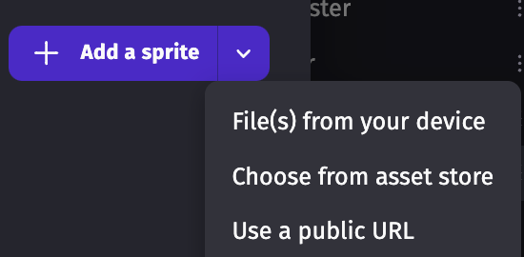

Select ‘Choose from asset store’ option.

- Browse and select the image file you want to use for your sprite.
- If you want to add more frames (for animation purposes), repeat the previous steps for each frame.

E. Add the Sprite to the Scene
- Drag and drop the sprite object from the Objects tab to the scene.
- Position the sprite where you want it in the scene by clicking and dragging it.

F. Adjust Properties (Optional)
- Select the sprite in the scene to see its properties in the Properties panel on the left.
- You can adjust properties such as position, scale, angle, and layer.

G. Preview Your Scene
- Click the Preview button (play icon) at the top right to run your scene and see your sprite in action.

Additional Tips (some steps will follow):
- Animations: If your sprite has multiple animations (e.g., idle, walk, jump), add each animation separately in the Object Properties panel.
- Collision Masks: Set up collision masks if your sprite needs to interact with other objects physically.
- Behaviors: Add behaviors like platformer or top-down movement by selecting the sprite and clicking the Behaviors tab in the Properties panel. You’ll do this next!

STEP 4 Create Behaviors for Sprites

Example behavior for a sprite follows

A. Add Behaviors to the Player Sprite
- Select the Player sprite in the Objects panel.
- In the properties panel, click on "Behaviors" and then "Add a behavior to the object".
- Add the "Top-Down Movement" behavior for basic movement or the "Platformer Character" behavior for platformer movement.
B. Configure the Behavior
- Configure the behavior settings as needed. For example, if you added the "Platformer Character" behavior, you can set the jump speed, max speed, gravity, etc.
C. Add Controls for the Player
- Switch to the Events tab for your scene.
- Add a new event for player controls. For example, to move the player using arrow keys:
  - Add a condition: "Key pressed" (choose the desired key, like Left, Right, Up, Down).
  - Add an action: "Simulate pressing [direction] key" for the Player object.
  - If you added the "Platformer Character" behavior, use the action "Simulate jump key" for the jump action.
D. Test the Game (optional)
- Click the preview button to test your game and see if the player behaves as expected.
Example Event Setup for a Platformer Character
- Condition: Key pressed (Right)
  - Action: Simulate pressing Right key for Player
- Condition: Key pressed (Left)
  - Action: Simulate pressing Left key for Player
- Condition: Key pressed (Up)
  - Action: Simulate pressing Up key for Player
Example Event Setup for a Top-Down Character
- Condition: Key pressed (Right)
  - Action: Simulate pressing Right key for Player
- Condition: Key pressed (Left)
  - Action: Simulate pressing Left key for Player
- Condition: Key pressed (Up)
  - Action: Simulate pressing Up key for Player
- Condition: Key pressed (Down)
  - Action: Simulate pressing Down key for Player

STEP 5 Set Events

Set up actions and conditions (example Player collides with Monster, scene switching, etc.) as follows

A. Set Up Conditions and Actions:
  - Switch to the "Events" tab for your scene.
  - Click on "Add a new event."
  - For each event, you can add conditions and actions as follows:
Example Event 1: Moving a Player
    - Condition: "Key pressed"
      - Click on "Add condition."
      - Select "Keyboard" and then "Key pressed."
      - Choose the key (e.g., "Right" or "Left").
    - Action: "Add a force to move the object"
      - Click on "Add action."
      - Select the object (e.g., "Player").
      - Choose the action "Add a force" (or "Add a force (angle)" for movement in a specific direction).
      - Set the force values to control the speed and direction of the movement.
Example Event 2: Shooting a Projectile
    - Condition: "Key pressed"
      - Click on "Add condition."
      - Select "Keyboard" and then "Key pressed."
      - Choose the key (e.g., "Space").
    - Action: "Create an object"
      - Click on "Add action."
      - Select "Create an object."
      - Choose the projectile object and set its position relative to the player.
Example Event 3: Collision Detection
    - Condition: "Collision"
      - Click on "Add condition."
      - Select "Collision" and then "Collision between two objects."
      - Choose the objects involved in the collision (e.g., "Player" and "Enemy").
    - Action: "Delete the object"
      - Click on "Add action."
      - Select the object to be deleted (e.g., "Enemy").
B. Test the Scene:
  - Click on the "Preview" button to test your scene and see the events in action.
C. Refine and Add More Events!
  - Add more events, conditions, and actions as needed to create the desired gameplay.
Here's how the Events Editor might look for these examples:

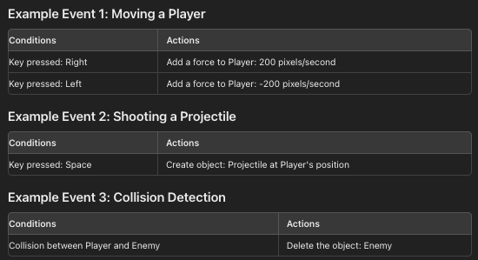

Sample example
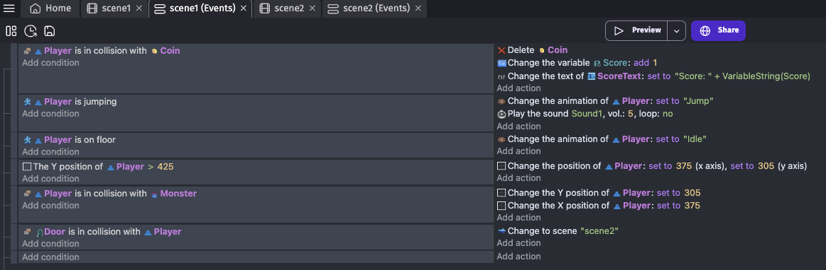

STEP 6 Preview your Build!

Save your build by clicking on your Saveicon in the upper right menu area as shown below.

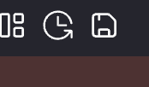

Next press 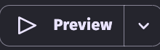 at the top center of your Build area to run your
game.

STEP 7 Adding an additional layer as a background

A .Click  at the bottom right of your scene area and give your layer a name like BG for ‘Background’.

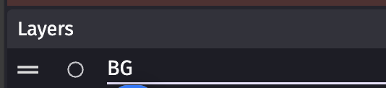

Next drag the layer so it sits below your default layer.

B. Add the Background Sprite:
Switch to the Objects tab on the right side of the screen.
Click the  and select Sprite.
Name your sprite (e.g., "BackgroundImage") and add the image you want to use as the background.
C. Place the Background Sprite:
Drag and drop your newly created background sprite onto the scene.
Make sure the sprite is positioned correctly. You might need to adjust its size and position to cover the entire scene.
D. Move the Background Sprite to the New Layer:
Select the background sprite on the scene.
In the Properties panel on the right side of the screen, find the Layer dropdown menu.
Select the new layer you created (e.g., "BG"). Snapshot follows.

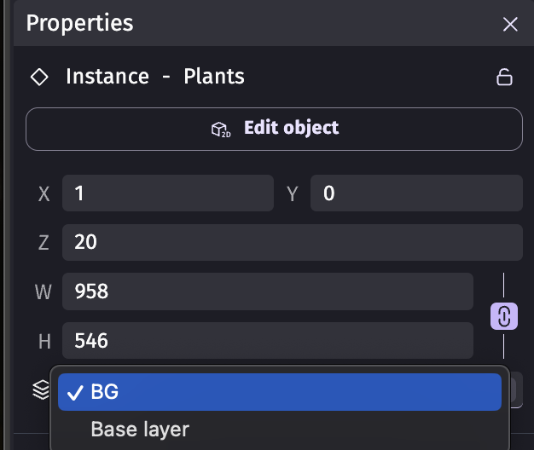

E. Adjust Layer Ordering:
Again, ensure that the background layer is below any other layers you want to be displayed above it. You can reorder layers in the Layers editor by dragging them up or down.
F. Preview Your Scene:
Click the Preview button to see how your background looks in the game.

STEP 8 Creating a 2nd Scene option

A. Add a New Scene:
  - Click on the "Project" tab in the top-left corner of the editor.
  - In the "Project Manager" panel that appears on the left side, find the "Scenes" section.
  - Click the "+" button next to "Scenes" to add a new scene.
  - Name your new scene (e.g., "Scene2") and press Enter.
B. Edit the New Scene:
  - Click on your newly created scene to open it.
  - Design and populate the scene with objects, backgrounds, and events as you did with your first scene.
C. Create a Way to Switch Scenes:
  - Open the first scene where you want to add the functionality to switch to the second scene.
  - Go to the "Events" tab.
  - Add a new event for the scene transition. For example, you can add a condition to check if a key is pressed (e.g., the space bar) or if the player collides with a specific object.
D. Add the Scene Transition Action:
  - Under the condition you added, click on "Add action."
  - Choose the action "Change the scene."
  - In the action parameters, select the name of the second scene you created (e.g., "Scene2").
E. Test Your Game (as always):
  - Run your game by clicking the "Preview" button (the play button at the top of the editor).
  - Ensure the scene transition works as expected when the specified condition is met.
Example Event for Scene Transition
Here's an example event that changes the scene when the space bar is pressed:
- Condition: Key "Space" is pressed
- Action: Change the scene to "Scene2"
Steps to Add This Event
- Open the first scene.
- Go to the "Events" tab.
- Click on "Add a new event."
- Click "Add condition" and choose "Keyboard > Key pressed" and select "Space."
- Click "Add action" and choose "Scene > Change the scene" and select "Scene2."

STEP 9 Preview once again your game in action!

Keep testing till perfection is reached. Take time to check everything to see if game play is fluid and functional.

STEP 10 Share your Build!

Once your satisfied with your build, save your game and when ready to share your build, press the  button and go to this Google Sheets link and add in your name in one column and link of your build in another column.

Make sure to press the  button as shown below.

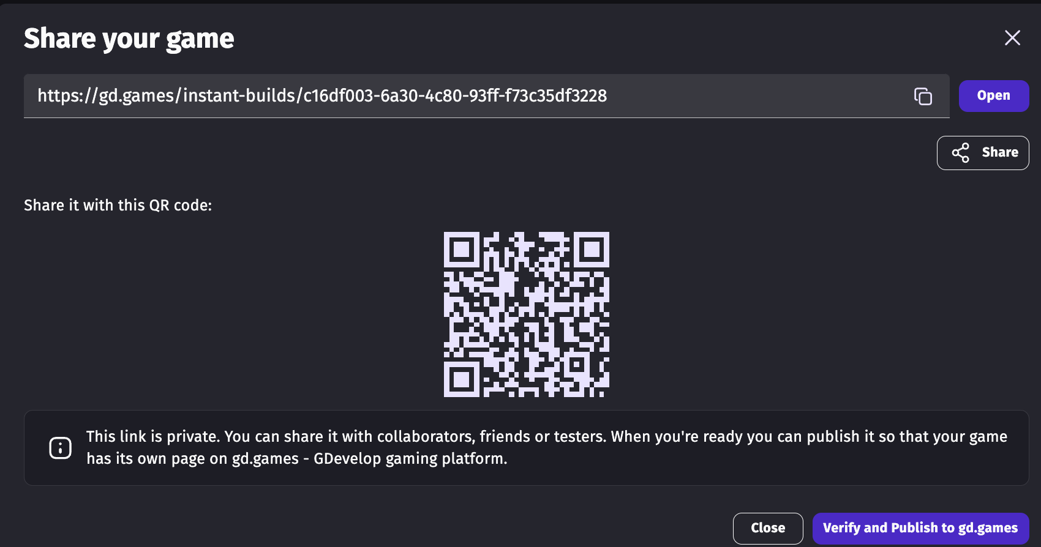

STEP 11 For Further Exploration

Asset references (highly recommended)

Piskel - Free online sprite editor (piskelapp.com)

OpenGameArt.org

Assets · Kenney

Creating a Platformer Game Without Coding - Part 1: Step-by-Step Tutorial

Other game ideas

MAZE: PATH OF LIGHT - Play Online for Free! | Poki

